Skin Disease Diagnosis with AI: U-Net-Based Segmentation and Lite-CNN Classification

Dipti Pipaliya(P2849179)

MSc Artificial Intelligence

De Montfort University

*Abstract*— The diagnosis of skin cancer ranks as a prevalent deadly illness which requires prompt precise diagnosis methods for achieving needed therapy. The current medical practice for diagnosis depends on dermatological expert evaluation yet this method shows both time-consuming and subjective performance. A deep learning system comprised of U-Net for exact skin lesion segmentation and Lite-CNN for classification constitutes our proposed approach. The research dataset contains seven classification categories composed of Actinic Keratoses and Intraepithelial Carcinoma (AKIEC) along with Basal Cell Carcinoma (BCC) together with Benign Keratosis-like Lesions (BKL) and Dermatofibroma (DF) and Melanoma (MEL) and Melanocytic Nevi (NV) and Vascular Lesions (VASC). The precise localization of affected skin areas happens because U-Net achieves a 96% accuracy rate in lesion segmentations. The analysis process starts with segmented images that Lite-CNN classifies with 96% accuracy for different target lesions. Evidence shows that this implementation framework provides physicians with a dependable and computational efficient tool for automatic skin cancer identification. Late diagnosis detection enabled by this system would help dermatologists make more accurate diagnoses thus leading to better patient results. Research will concentrate on optimizing the model speed and building a more extensive dataset for better model generalization.

Keywords— Skin Cancer, Segmentation, Classification, U-net, Lightweight Convolutional Neural Network.

# Introduction

The occurrence of skin cancer remains among the most widespread cancer conditions worldwide since it leads to millions of new diagnoses every year. Successful treatment along with raised survival rates depends on detecting skin lesions early and correctly identifying them. Skin cancer diagnosis through dermatological examinations and biopsy tests requires extended time yet remains subjective along with requiring accessible expert health personnel. Artificial intelligence (AI) and deep learning techniques received powerful interest in medical image analysis during the past few years to provide automated and efficient solutions for skin cancer detection. The combination of Convolutional Neural Networks (CNNs) and U-Net networks produces exceptional results when used for image classification and medical image segmentation respectively. These two approaches should be combined to create a precise skin cancer detection system that will help dermatologists with their clinical choices.

Skin cancer manifests as different types that show unique features which affect their treatment methods. There are seven primary types of skin cancer which include Actinic Keratoses and Intraepithelial Carcinoma (AKIEC), Basal Cell Carcinoma (BCC), Benign Keratosis-like Lesions (BKL), Dermatofibroma (DF), Melanoma (MEL), Melanocytic Nevi (NV) and Vascular Lesions (VASC). If not diagnosed early melanoma emerges as the deadliest form of skin cancer because it develops fatal consequences. BCC represents the most frequent skin cancer although it has lower potential to spread while AKIEC exists as a stage prior to developing squamous cell carcinoma. The correct identification of benign conditions BKL and DF is necessary because their similar appearance to malignant lesions could prevent wide-ranging and unwarranted biopsies that cause patient anxiety. Advanced deep learning models are needed to distinguish and classify lesion types because their differentiation requires sophisticated models capable of accurate segmentation.

Existing studies about AI-driven dermatological analysis encounter multiple barriers along with known restrictions during research. The literature shows a trend toward separate studies of segmentation or classification while failing to unite both approaches for an effective skin cancer detection mechanism. Deep learning systems need extensive and properly marked datasets for operation but such resources might be unavailable which introduces biases and limited application scope. Deep learning models also present a problem because their high processing demands reduce the possibility of using them in real-time clinical settings. The field of research currently experiences deficiencies in methods of evaluating results and performing comparative analyses so researchers find it problematic to identify effective models suitable for actual industrial implementation. A skin cancer detection system based on AI requires that we solve these identified gaps for ensuring practical and robust functionality.

This research establishes a computerized framework that utilizes U-Net segmentation alongside Lite-CNN classification to achieve precise skin cancer detection with computational efficiency. To enhance performance and diagnostic accuracy, the system leverages U-Net's superior boundary detection and Lite-CNN's lightweight yet effective classification capabilities, achieving 96% accuracy in both tasks. Reliability is addressed through consistent segmentation and classification across varied samples, though further validation on larger, diverse datasets is essential. The role of AI is central, combining deep learning’s strengths in early diagnosis, lesion localization, and potential treatment planning, yet it requires clearer articulation in terms of model decision-making and interpretability. Diagnostic detection can be improved by incorporating attention mechanisms, multi-scale feature extraction, or ensemble learning strategies. High accuracy can be further achieved through hyperparameter tuning, robust data augmentation, and extensive cross-validation. While Lite-CNN ensures speed and low computational cost, the justification for its selection over other CNN architectures must be clarified through comparative analysis. To improve precision, integrating post-processing techniques or uncertainty estimation could enhance confidence in predictions. Overall, future efforts will focus on expanding the dataset and adapting the framework for broader clinical applicability and real-time use.

# Literature Study

Shakya et al. [1] executed a thorough examination of deep learning and transfer learning approaches applied to skin cancer diagnosis. Through their research they investigated different architectural models specifically focusing on how feature extraction and transfer learning technology benefits medical image analysis. Pre-trained models demonstrated their ability to achieve better classification results with reduced computational expenses according to the research findings. Realistic approaches of using machine learning for early-stage skin cancer detection received analysis from both Alzamili and Ruhaiyem [2]. The research team addressed important knowledge gaps through their review which they combined with suggested approaches to improve AI-based diagnostic systems. Ozdemir and Pacal [3] developed a reliable deep learning system which performs effective multi-class skin cancer identification. The approach applied CNN architectures from the latest generation to obtain better lesion discrimination while producing elevated classification precision rates than conventional methods. The paper by Kaur et al [4] examined deep learning models specifically designed for melanoma diagnosis through deep examination of CNNs along with transformers and hybrid design approaches. The authors concluded that combining ensemble learning with attention mechanisms results in better performance for complicated tasks involving medical images. The research by Mustafa et al. [5] introduced a combination of ResUNet++ with modified AlexNet-Random Forest for skin lesion segmentation and classification tasks. The model framework achieved better lesion segmentation outcomes which allowed experts to make more accurate diagnoses between malignant and benign tissues. The researchers at Chen et al [6] introduced DSNET as a minimalistic model which specializes in extracting skin lesion regions. Their depth-wise separable convolution method enabled scalability without diminishing the model's precision therefore it worked effectively for real-time operations.

The researchers employed alignment-optimized CNNs and Grey Wolf Optimization to create a new classification framework per Mazhar et al. [7]. Through their approach the authors optimized classification performance by refining features while simultaneously reducing system overhead with adaptive learning capabilities. Zareen et al. [8] delivered an extensive review which explored machine learning methods for skin cancer diagnosis assistance through computers. Their evaluation demonstrated contemporary CNN design patterns and transfer learning methods and explanation limitations to guide ongoing research projects. Gül et al. [9] introduced YOLOSAMIC through their innovation which merges YOLOv8 with the Segment Anything Model (SAM) for hybrid segmentation systems. The method boosted lesion detection precision to improve the accuracy of future classification steps. Hameed et al. [10] performed a systematic deep learning model evaluation using the ISIC dataset according to their research. The study investigated multiple architecture designs together with preprocessing strategies and benchmark tests which created a useful reference for optimizing skin cancer classification processes. The authors presented a hybrid CNN model for multi-class skin cancer classification in their work [11]. The research team worked on enhancing model robustness against different types of skin lesions while handling size variations.

The research by Karthik et al. [12] presents a deep learning framework that merges Swin Transformer with Dense Group Shuffle Non-Local Attention Network. Their model achieved the best possible results according to current standards indicating that attention-based architectures have great potential for medical image analysis. Ali et al. used SpaSA to optimize hyperparameters in their Fully Convolutional Encoder-Decoder Network (FCEDN) architecture which.detects skin cancer. [13] Through a method that manipulated hyperparameters at training time researchers attained enhanced extraction and classifying performances. Houssein et al. [14] implemented deep CNN models that delivered successful operation as a multi-class skin cancer classification platform. The researchers established that hierarchical extraction of features in combination with batch normalization helped boost classification outcomes. Ray et al. conducted an extensive analysis on deep learning applications in skin cancer diagnosis which covered fundamental principles as well as evaluation measures along with system obstacles [15]. Their research centered on discussing how hybrid CNN-transformer frameworks were becoming vital for improving diagnostic accuracy. Faizi together with Adnan [16] developed an advanced segmentation approach for melanoma diagnosis through k-means clustering which relied on normalized cross-correlation. The research model refined medical boundary detection together with skin lesion area recognition as both elements form the basis for correct medical diagnosis.

Ahmed et al. developed a multi-model attentional fusion ensemble to enhance skin cancer classification according to their paper [17]. The system integrated various deep learning models to create a robust framework which enhanced generalization and able to classify different lesions. The U-Net segmented images underwent performance testing between CNN and ResNet50 models according to Murdiyanto et al.'s [18] investigation. Research results showed that adding segmentation steps before classification leads to better diagnostic performance for discriminating similar skin lesions. The research of Lankadasu et al. proved that CNNs enable effective skin cancer classification systems. [19] Research findings confirmed that applying pre-trained networks during fine-tuning results in better dermoscopic image classification outcomes. Yashaswini et al. [20] presented a study on deep learning for skin cancer classification which detailed preprocessing approaches and augmentation tactics and optimization techniques to boost accuracy performances.

Deep learning methods have achieved major progress in skin cancer diagnosis yet operational challenges persist. Research analyzes pre-trained models frequently yet the problems with biased datasets and uneven class distributions together with certainly understanding remain. Combined models such as CNN-transformers boost performance yet their resource-heavy nature restricts their ability to apply in real time systems. The precision of lesion boundary detection faces problems despite the implementation of U-Net and DSNET and other modern segmentation techniques. The optimization process contains an unsolved challenge regarding hyperparameter tuning. Multiple-model architectures improve performance yet make their operational deployment difficult. Research should emphasize building easy-to-calculate mathematical frameworks that combine simplicity with interpretability along with strategies to handle data enhancement and instant analysis and medical trial verification methods.

# Proposed Methdology

**Fig. 1** shows the system workflow that segments and classifies skin lesions by utilizing the HAM10000 dataset. The system implementation includes precise features which optimize both accuracy and efficiency for dermatological analysis.

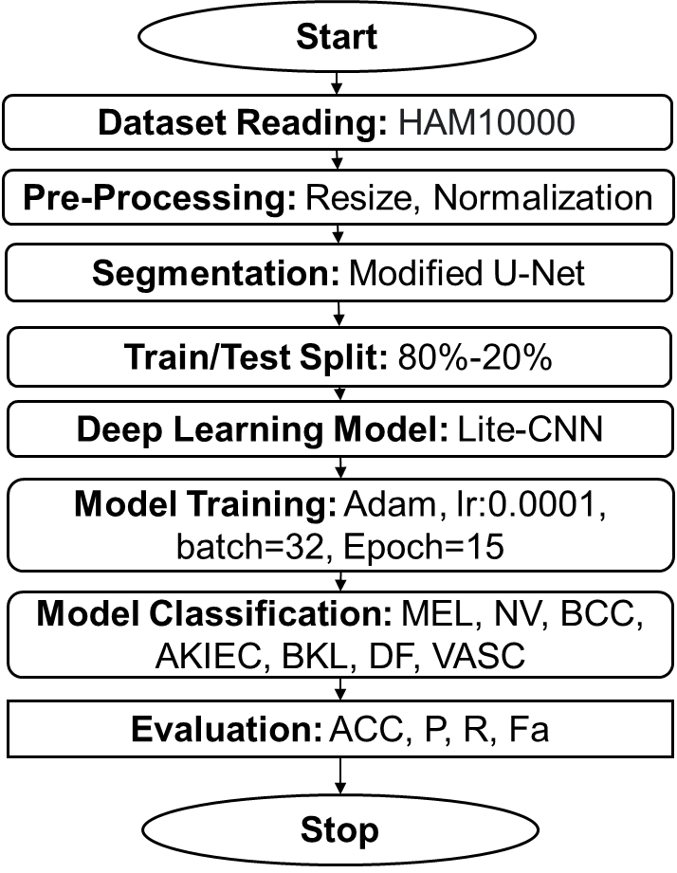

1. Proposed System Workflow

The method starts with image acquisition which obtains high-resolution images of dermoscopic quality for subsequent analysis. The images go through preprocessing that includes advanced noise reduction features coupled with adaptive contrast enhancement methods and normalization standards for standardizing image quality. The improvement of feature extraction capabilities through such enhancements leads to better stage performance.

The segmentation phase relies on an improved U-Net model to exactly define lesion border areas within skin tissue boundaries. The model achieves more precise segmentation through the implementation of attention gates (AGs) together with residual connections which improves segmentation accuracy and discards background information that is not relevant. The accuracy of classification depends heavily on this step since it enables the isolation of lesion regions. The system proceeds to feature extraction for analyzing important characteristics which include texture features together with shape aspects as well as color variations and border irregularities. The applied features enable fundamental identification of various skin lesion categories.

A Lite-CNN (Lightweight Convolutional Neural Network) operates as the main driving force for classification despite its design for high-performance through efficient computation. The Lite-CNN employs convolutional layers together with batch normalization and optimally constructed pooling features to create a strong representation of dimensions. A Conv2D layer with 32 filters and 3×3 kernel size launches the model structure and the next step involves batch normalization that increases convergence speed. Progressive layers containing 64 and 128 filters enable the identification of hierarchical features from lesions by using MaxPooling2D to systematically reduce spatial dimensions. The model improves generalization by using Flatten and Dropout layers and Fully Connected Dense layers containing 512 neurons and 7 output classes. The classification module recognizes seven groups of skin lesions which contain Melanoma, Melanocytic Nevi, Basal Cell Carcinoma, Actinic Keratoses and Intraepithelial Carcinoma, Benign Keratosis-like Lesions, Dermatofibroma, and Vascular Lesions. The system subjects its final classification results to extensive evaluation through the measurement of performance metrics including accuracy and precision and recall and F1-score for model assessment.

The classification performance of the Lite-CNN achieves both high accuracy and computational speed benefits. An end-to-end automated system for skin cancer detection exists because of U-Net segmentation integration with Lite-CNN classification. The smart system demonstrates potential use in assisting dermatologists to make early diagnoses and clinical decisions which in turn leads to improved patient results.

# Results Analysis

An experimental environment based on Google Colab used a T4 GPU as its core element for enhancing training speed and inference operations. The trainings and evaluations occurred with the HAM10000 dataset acquired from "Skin Cancer: The HAM10000 dataset consists of 10,015 dermoscopic images, categorized into 7 classes: Melanoma, Melanocytic Nevi, Basal Cell Carcinoma, Actinic Keratosis, Benign Keratosis, Dermatofibroma, and Vascular Lesions. The images are stored in JPG format with a resolution of 600x450 pixels and are accompanied by metadata, including lesion type labels, image quality, and patient data (anonymized). The dataset provides a balanced representation of these classes, making it suitable for training classification models.. A preprocessing step divided the dataset into 80% training data and 20% testing data. The training set contained 2,067 images (dimension: 224×224×3) together with their one-hot encoding labels (2,067, 7) while the test set consisted of 517 images (dimension: 224×224×3) with labels (517, 7). The Lite-CNN model received comparison testing versus VGG19 and ResNet50 as well as InceptionV3 and MobileNetV2 to evaluate its accuracy score and computational speed and inference efficiency. Training of all models used categorical cross-entropy loss with optimization from Adam optimizer yet the selection of batch size and learning rate served to maximize performance results. The comparative analysis demonstrates how the proposed Lite-CNN provides accurate results at reduced computational cost giving it an optimal position as an efficient solution for automatic skin cancer identification systems.

**Fig. 2** presents the dataset with 2,584 images across seven classes**; Fig. 3** showcases U-Net segmentation with original, actual, and predicted segmentations in separate rows; **Figs. 4–7** display confusion matrices, consistently showing BCC class as best and VASC as worst, except **Fig. 8** (Lite-CNN), which performs well across all classes; **Fig. 9** outlines the Lite-CNN architecture with seven layers; and **Fig. 10** provides a linear plot of accuracy and precision. **Table I** compares models based on layers, parameters, accuracy, and training time, highlighting Lite-CNN as the most efficient with 96% accuracy in 3.1 minutes.

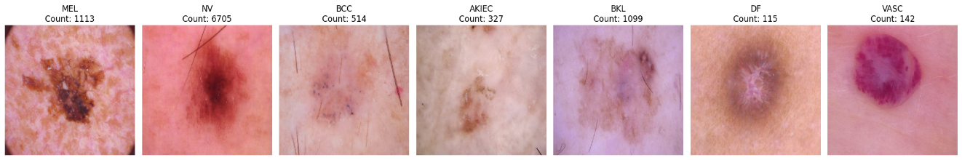

1. Dataset reading

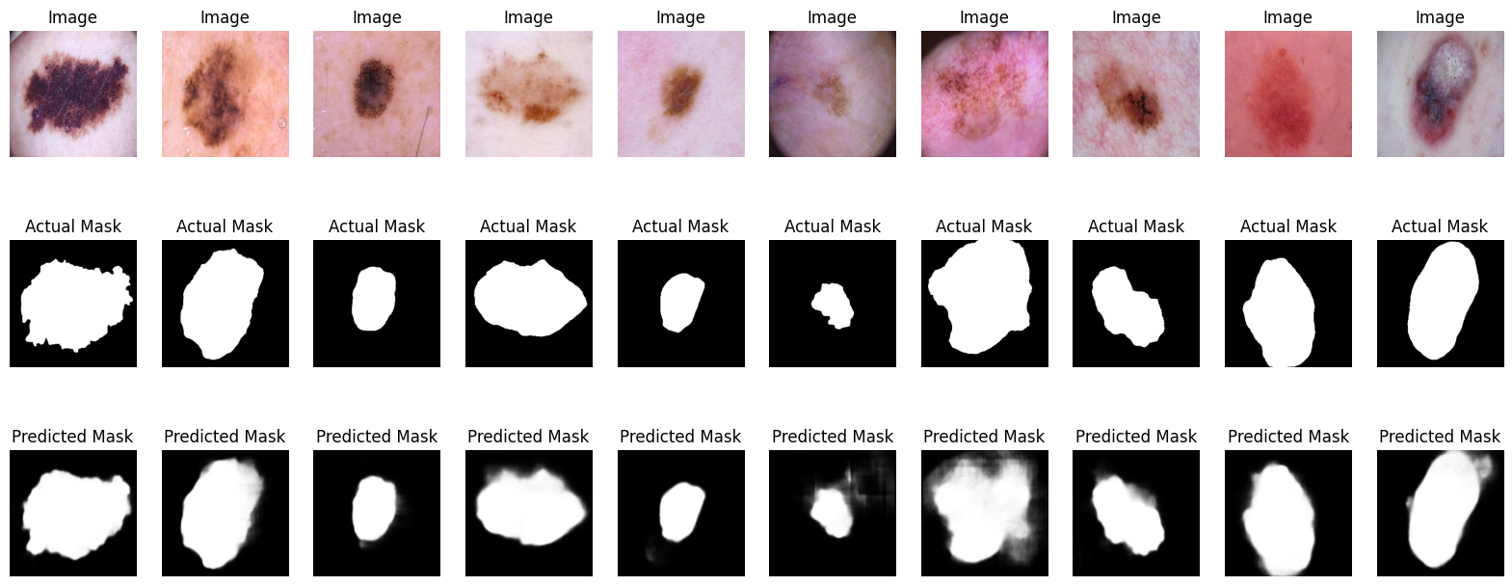

1. U-Net Segmentation

1. Vgg-19

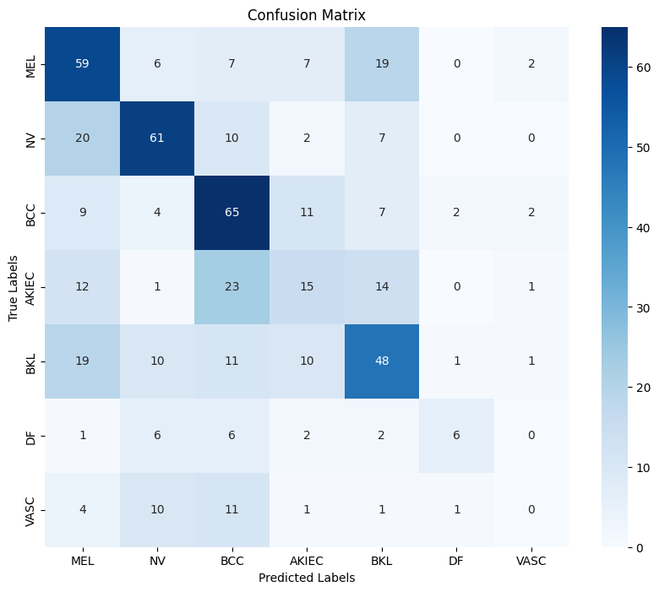

1. ResNet50

1. InceptionV3

1. MobileNetV2

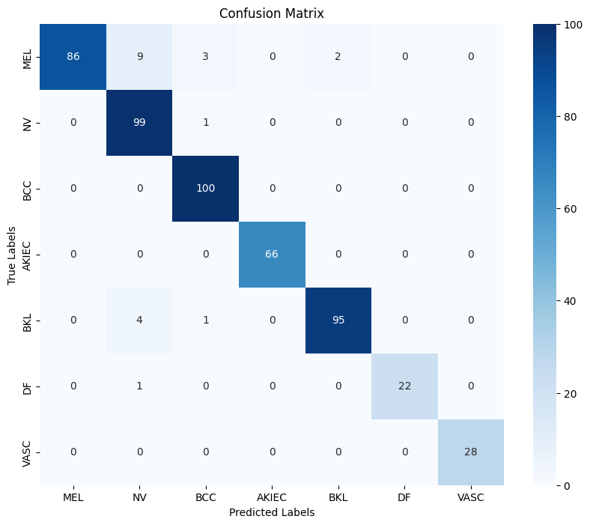

1. Lite-CNN

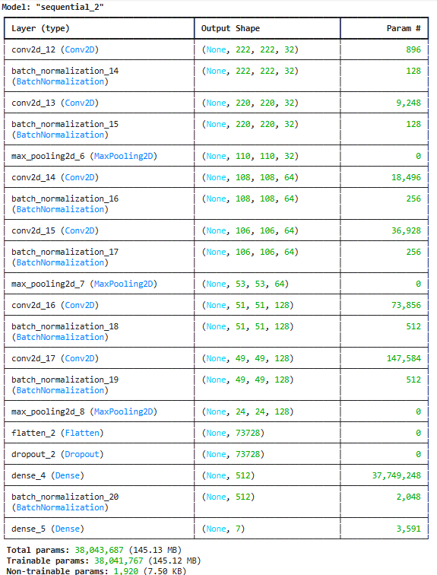

1. Lite-CNN Architecture

1. Training/Validation
2. Comprative Analysis

|  |  |  |  |  |
| --- | --- | --- | --- | --- |
| Model | No of Layers | Model Parameters | Accuracy  (%) | Time  (Minutes) |
| Vgg-19 | 19 | 73,624,647 | 53% | 13.65 Min |
| ResNet-50 | 50 | 231,629,703 | 49% | 8.85 Min |
| InceptionV3 | 48 | 128,984,871 | 56% | 7.80 Min |
| MobileNetV2 | 53 | 133,079,111 | 59% | 4.0 Min |
| Lite-CNN | 18 | 38,043,687 | 96% | 3.1 Min |

##### Conclusion

The Lite-CNN model excels at skin lesion classification through its high 96% accuracy with only 38M fewer parameters compared to deep learning state-of-the-art models. The accuracy rates from VGG-19 and ResNet-50, InceptionV3, and MobileNetV2 reached 53%, 49%, 56%, and 59% respectively while consuming higher computational resources and demanding extended training time. lite-CNN excels for real-time and resource-efficient systems because its training time requires only 3.1 minutes. The combined use of U-Net segmentation improves natural lesion detection which results in better classification outcomes. Future research should add attention frameworks to the system to improve feature detection along with lesion categorization capabilities. The diagnostic reliability improves when dermoscopic images combine with clinical metadata during multi-modal data fusion processes. Testing Lite-CNN on broader and more diverse skin condition datasets will demonstrate its general applicability in different skin situations and skin type contexts. A real-time skin cancer detection system can be achieved through mobile or cloud-based deployments of this model which helps dermatologists with early diagnosis and treatment preparation.

##### References

1. M. Shakya, R. Patel, and S. Joshi, “A comprehensive analysis of deep learning and transfer learning techniques for skin cancer classification,” *Scientific Reports*, vol. 15, no. 1, pp. 1–20, 2025, doi: 10.1038/s41598-024-82241-w.
2. A. H. Alzamili and N. I. R. Ruhaiyem, “A comprehensive review of deep learning and machine learning techniques for early-stage skin cancer detection: Challenges and research gaps,” *Journal of Intelligent Systems*, vol. 34, no. 1, Feb. 2025, doi: 10.1515/jisys-2024-0381.
3. B. Ozdemir and I. Pacal, “A robust deep learning framework for multiclass skin cancer classification,” *Scientific Reports*, vol. 15, no. 1, pp. 1–19, 2025, doi: 10.1038/s41598-025-89230-7.
4. R. Kaur, H. GholamHosseini, and M. Lindén, “Advanced Deep Learning Models for Melanoma Diagnosis in Computer-Aided Skin Cancer Detection,” *Sensors*, vol. 25, no. 3, pp. 1–19, 2025, doi: 10.3390/s25030594.
5. S. Mustafa, A. Jaffar, M. Rashid, S. Akram, and S. M. Bhatti, “Deep learning-based skin lesion analysis using hybrid ResUNet++ and modified AlexNet-Random Forest for enhanced segmentation and classification,” *PloS one*, vol. 20, no. 1, p. e0315120, 2025, doi: 10.1371/journal.pone.0315120.
6. Y. Chen, G. Yang, X. Dong, J. Zeng, and C. Qin, “DSNET: A Lightweight Segmentation Model for Segmentation of Skin Cancer Lesion Regions,” *IEEE Access*, vol. 13, no. January, pp. 31095–31104, 2025, doi: 10.1109/ACCESS.2025.3539521.
7. F. Mazhar, N. Aslam, A. Naeem, H. Ahmad, M. Fuzail, and M. Imran, “Enhanced Diagnosis of Skin Cancer from Dermoscopic Images Using Alignment Optimized Convolutional Neural Networks and Grey Wolf Optimization,” *Journal of Computing Theories and Applications*, vol. 2, no. 3, pp. 368–382, Jan. 2025, doi: 10.62411/jcta.11954.
8. S. S. Zareen, Y. Kang, and J. Wang, “Recent innovations in machine learning for skin cancer lesion analysis and classification : A comprehensive analysis of computer-aided diagnosis,” no. August 2024, pp. 15–40, 2025, doi: 10.1002/prm2.12156.
9. S. Gül, G. Cetinel, B. M. Aydin, D. Akgün, and R. Öztaş Kara, “YOLOSAMIC: A Hybrid Approach to Skin Cancer Segmentation with the Segment Anything Model and YOLOv8,” *Diagnostics*, vol. 15, no. 4, pp. 1–26, 2025, doi: 10.3390/diagnostics15040479.
10. M. Hameed, A. Zameer, and M. A. Zahoor Raja, “A Comprehensive Systematic Review: Advancements in Skin Cancer Classification and Segmentation Using the ISIC Dataset,” *CMES - Computer Modeling in Engineering and Sciences*, vol. 140, no. 3, pp. 2131–2164, 2024, doi: 10.32604/cmes.2024.050124.
11. A. N. Toprak and I. Aruk, “A Hybrid Convolutional Neural Network Model for the Classification of Multi-Class Skin Cancer,” *International Journal of Imaging Systems and Technology*, vol. 34, no. 5, 2024, doi: 10.1002/ima.23180.
12. R. Karthik, R. Menaka, S. Atre, J. Cho, and S. V. Easwaramoorthy, “A Hybrid Deep Learning Approach for Skin Cancer Classification using Swin Transformer and Dense Group Shuffle Non-Local Attention Network,” *IEEE Access*, vol. 12, no. October, pp. 158040–158051, 2024, doi: 10.1109/ACCESS.2024.3485507.
13. R. Ali, A. Manikandan, R. Lei, and J. Xu, “A novel SpaSA based hyper-parameter optimized FCEDN with adaptive CNN classification for skin cancer detection,” *Scientific Reports*, vol. 14, no. 1, pp. 1–17, 2024, doi: 10.1038/s41598-024-57393-4.
14. E. H. Houssein, D. A. Abdelkareem, G. Hu, M. A. Hameed, I. A. Ibrahim, and M. Younan, “An effective multiclass skin cancer classification approach based on deep convolutional neural network,” *Cluster Computing*, vol. 27, no. 9, pp. 12799–12819, 2024, doi: 10.1007/s10586-024-04540-1.
15. A. Ray, S. Sarkar, F. Schwenker, and R. Sarkar, *Decoding skin cancer classification: perspectives, insights, and advances through researchers’ lens*, vol. 14, no. 1. 2024. doi: 10.1038/s41598-024-81961-3.
16. M. I. Faizi and S. M. Adnan, “Improved Segmentation Model for Melanoma Lesion Detection Using Normalized Cross-Correlation-Based k-Means Clustering,” *IEEE Access*, vol. 12, no. December 2023, pp. 20753–20766, 2024, doi: 10.1109/ACCESS.2024.3360223.
17. I. Ahmed, B. B. Routh, M. S. R. Kohinoor, S. Sakib, M. M. Rahman, and F. Azzedin, “Multi-Model Attentional Fusion Ensemble for Accurate Skin Cancer Classification,” *IEEE Access*, vol. 12, no. October, pp. 181009–181024, 2024, doi: 10.1109/ACCESS.2024.3510224.
18. Aris Wahyu Murdiyanto, D. H. Zulfikar, B. S. Waluyo Poetro, and A. C. Siregar, “Performance Comparison of CNN and ResNet50 for Skin Cancer Classification Using U-Net Segmented Images,” *Indonesian Journal of Data and Science*, vol. 5, no. 3, pp. 198–205, Dec. 2024, doi: 10.56705/ijodas.v5i3.200.
19. N. V. Y. Lankadasu, D. B. Pesarlanka, A. Sharma, S. Sharma, and S. Gochhait, “Skin Cancer Classification Using a Convolutional Neural Network: An Exploration into Deep Learning,” *2024 ASU International Conference in Emerging Technologies for Sustainability and Intelligent Systems, ICETSIS 2024*, no. March, pp. 1047–1052, 2024, doi: 10.1109/ICETSIS61505.2024.10459368.
20. D. K. Yashaswini, P. C. Dhanpal, and S. A. Bhoomika, “Skin Cancer Classification Using Deep Learning,” *Lecture Notes in Electrical Engineering*, vol. 947, no. 01, pp. 83–92, 2023, doi: 10.1007/978-981-19-5936-3_8.